Create a Collection and Insert Documents solution

Q1.



Q2.

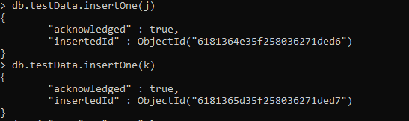



Q3.

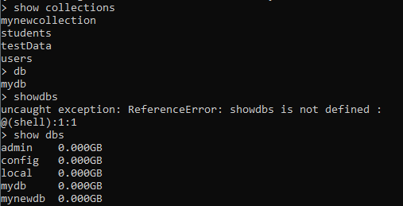

Q4.

